

Digital Literacy Project Report

(2025-26)

Name: Naman Gupta
Reg. No.: 25BAI448
Branch: CSE (AI&ML)
Course Code: CSE0001
Faculty: Dr. Kannan
Date:30 March 2026

Task 1 – Digital Literacy Infographic

For this task, I created a digital literacy awareness
infographic using Canva. The infographic explains
what digital literacy is and why it is important for
students. It includes key topics such as safe internet
practices, useful digital tools, and maintaining a
professional online presence.

I used simple icons, headings, and short descriptions
to make the design visually appealing and easy to
understand. The goal was to ensure that anyone
viewing the infographic could quickly grasp the key
ideas.

One challenge I faced was balancing text and
visuals. Initially, the design looked overcrowded, so
I had to simplify the content and focus only on
important points. This helped me improve my design
and presentation skills.

Overall, this task helped me learn how to present
information creatively and effectively.
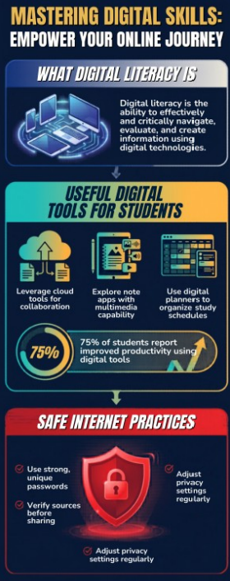

DL INFOGRAPHIC
Task 2 – Student Digital Portfolio

In this task, I created and updated my profiles on GitHub, LinkedIn,
and Kaggle. These platforms are important for building a strong digital presence.

GitHub is used to showcase coding projects and technical skills. I
created a profile README including my basic details and learning
goals. LinkedIn helps in building a professional network and
presenting my educational background. Kaggle is useful for practicing coding and improving problem-solving skills.

In the coming years, I plan to regularly update my GitHub with
projects, enhance my LinkedIn profile with achievements, and
continue solving problems on Kaggle. These platforms will help me
prepare for internships and job opportunities.
This task made me realize the importance of maintaining a
professional and active online presence.
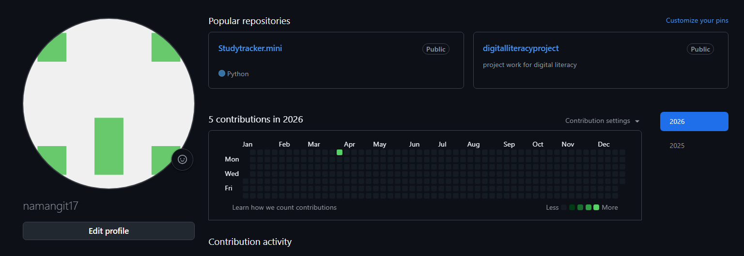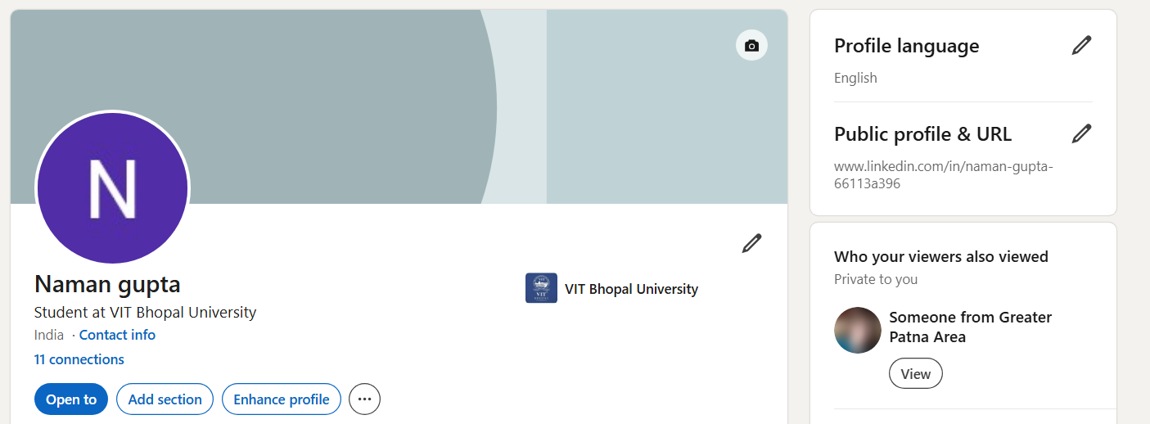
.

GITHUB PROILE
KAGGLE PROFILE
LINKDIN PROFILE
Task 3 – Coding & Collaboration Platforms
For this task, I used CODECHEF to complete a beginner-level coding challenge. This helped me understand basic programming concepts and improve my logical thinking.

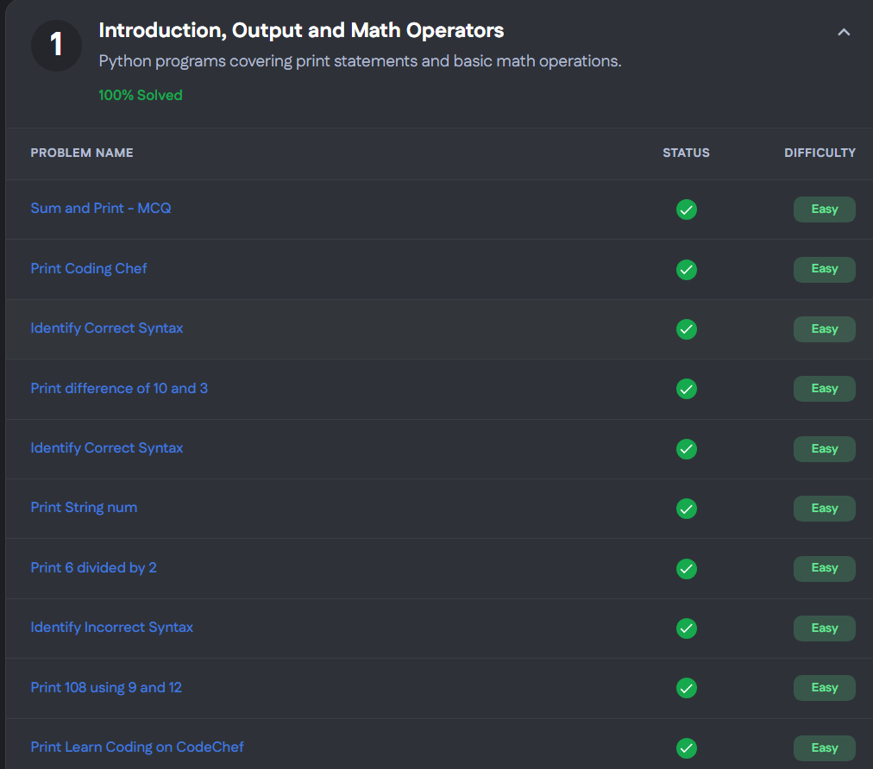
CODECHEF TASK

I also created a Google Form as a Digital Literacy Awareness Quiz.
The form includes five questions such as multiple-choice and short-answer questions. It can be used to test students’ understanding of digital literacy.
Creating the form helped me learn how to collect responses and
analyze data using Google Sheets. This is useful for surveys, feedback collection, and academic purposes.

These tools are very helpful for students. CODECHEF improves coding skills, while Google Forms supports collaboration and data collection. Both will be useful throughout my academic journey

Google Forms Link: https://forms.gle/zrBwFxQaYvUuTcYi6

Task 4 – Email Etiquette & Communication

In this task, I wrote two professional emails—one requesting an
assignment extension and another applying for an internship. I
followed proper email etiquette, including clear subject lines, polite
greetings, structured content, and professional closing.

I also created a checklist of social media do’s and don’ts to promote
responsible online behavior among students.

Poor digital communication can lead to misunderstandings and create a negative impression. For example, sending informal or unclear emails to professors can affect credibility. This can be avoided by maintaining professionalism and clarity in communication.

This task helped me understand the importance of proper
communication in academic and professional environments.

Task 5 – CybercrimeAwareness

For this task, I studied phishing as a cybercrime. Phishing involves
tricking users into sharing sensitive information through fake emails or websites.

What surprised me most was how realistic phishing attacks can appear, making them difficult to identify. Many people fall victim due to lack of awareness.

After completing this task, I will be more cautious while clicking on
links and will always verify the authenticity of emails and websites
before sharing any personal information.

This task helped me understand the importance of cybersecurity and
safe internet practices.

Conclusion

This project helped me develop essential digital literacy skills such as creating visual content, building a professional online presence, using collaboration tools, and understanding cybersecurity.

Each task provided practical knowledge and improved my confidence in using digital platforms. These skills will be highly useful in my academic journey and future career.

Overall, this project was a valuable experience that highlighted the
importance of responsible and effective use of digital technologies.

References

• Canva – https://www.canva.com

• GitHub – https://github.com

• LinkedIn – https://www.linkedin.com

• CodeChef – https://www.hackerrank.com

• Google Forms – https://forms.google.com

• National Cyber Crime Portal – https://cybercrime.gov.in

